**Make BLUESTACK Your Emulator in Android Studio. (**It will make run time fast and can work in low internet connection**.)**

1. First Install Bluestack 4 or 3 in your system.

2.Login Your id in Playstore.

3.Download **Rotation Control** app, Because will give run time output in Landscaape mode default so fix this issue we need this app.

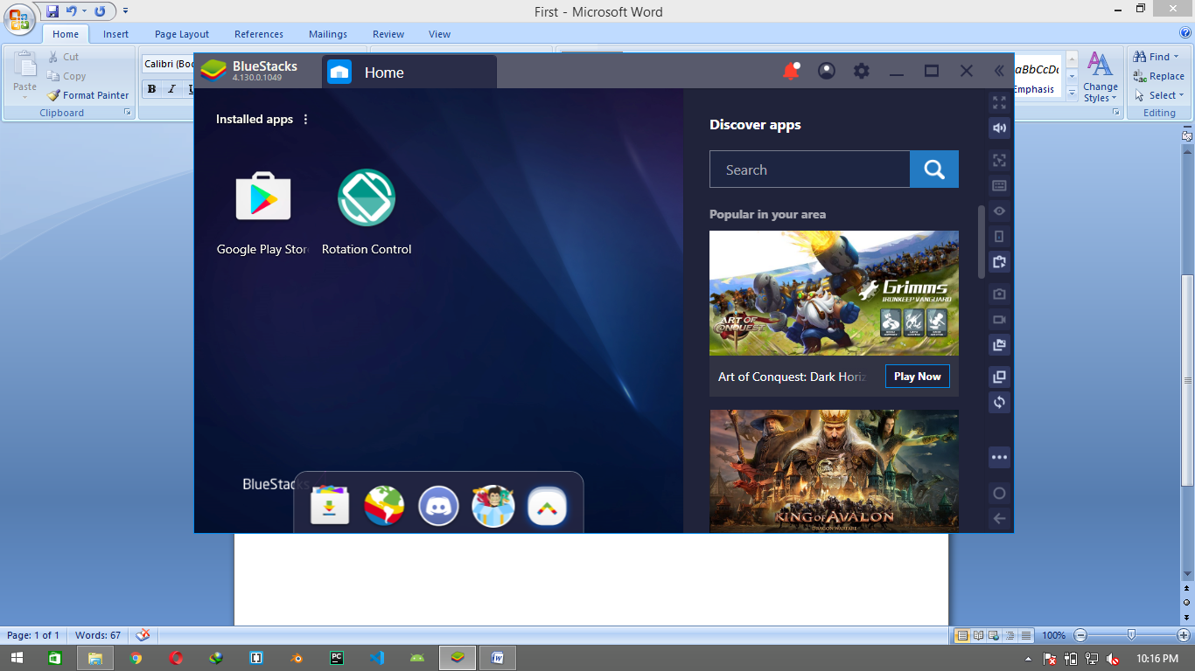

4. Now Enable the developer mode in BlueStack.By following step.

**4.1** click on the setting button on the taskbar.

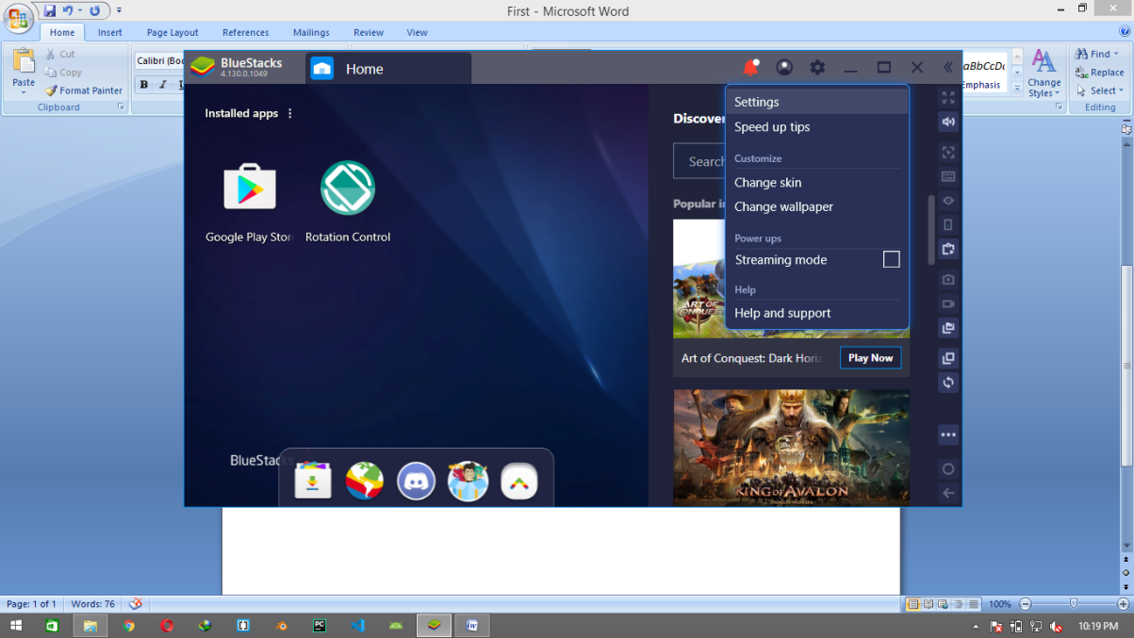

**4.2** click on the setting menu.

**4.3** Go to **Preference** and then enable **Android Debug Bridge.**

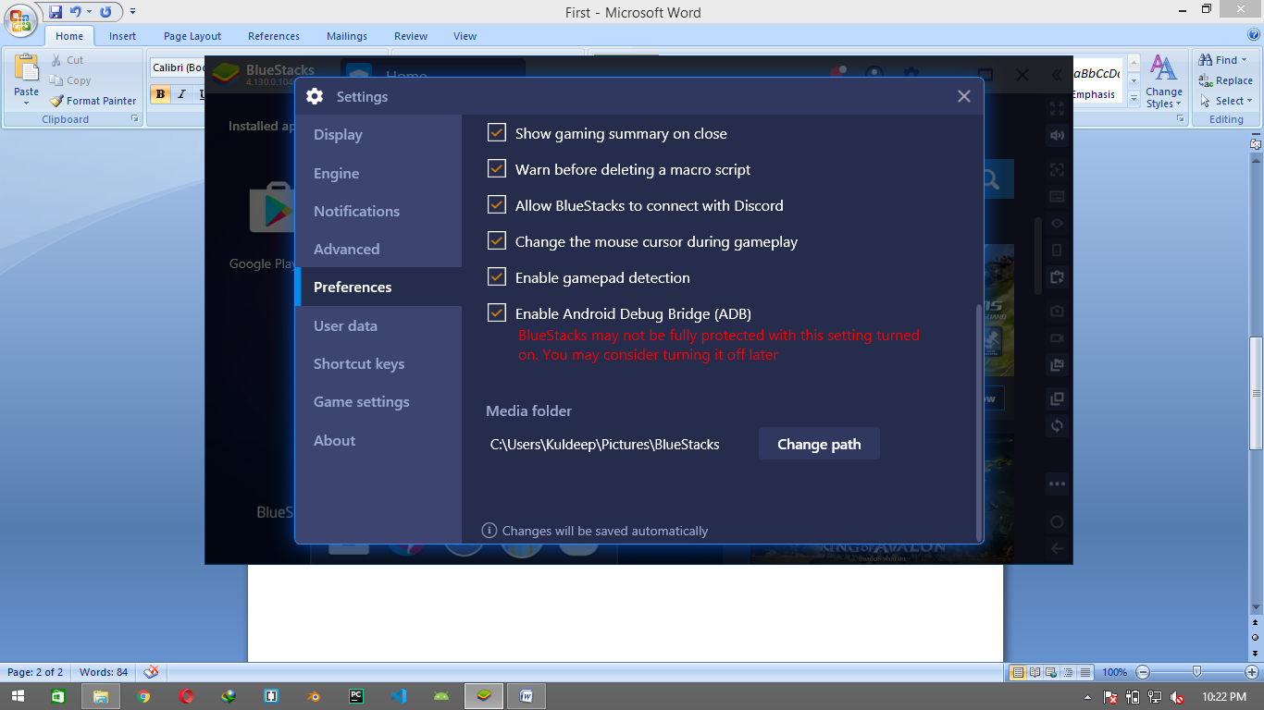

**5.** Now go to this folder in Explorer**. %LOCALHOST%\AppData\Local\Android\Sdk\platform-tools\** and execute the **adb.exe .** ( This execution is allow your android studio to access the root of your system so can android studio detect the BlueStack. )

Now **OPEN** The Android Studio and run your project the **AVD** Now automatically detect the Bluestack machine and run your project on that .

IN MY CASE MY ANDROID STUDIO **sdk min version** id 29 but my bluestack sdk version is 25 so I change the **min sdk version** from 29 to 25.

**HERE IS THE OUTPUT**

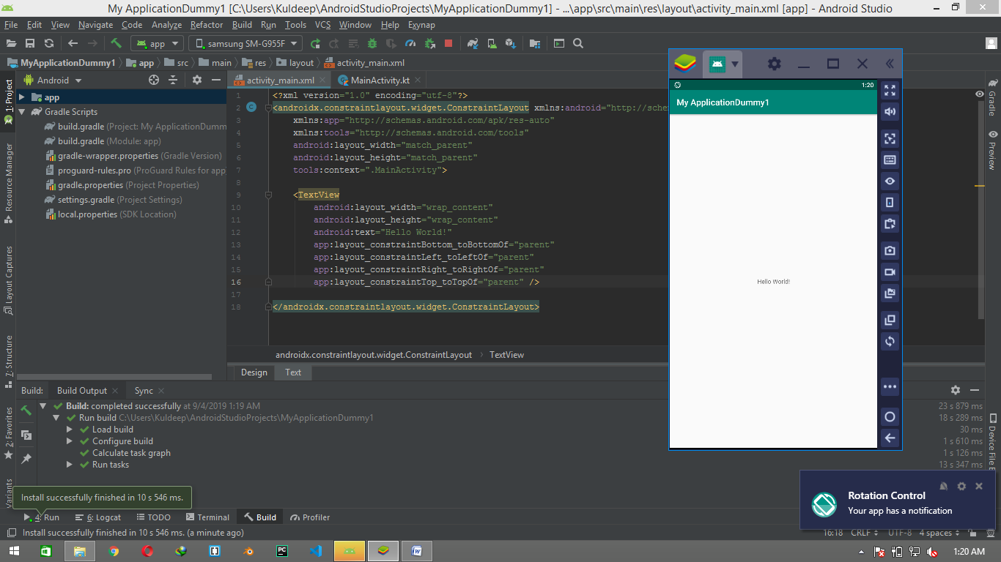

**SOME GENERAL ISSUES YOU CAN FACE LIKE.**

While running the Project on Bluestack You can see a runtime installation error

**“The application's minSdkVersion is newer than the device API level.”**

if anyone seeing this type of error then user can follow below steps:-

1. Open your Project. Click on **File>Project Struture.**
2. Go to **Modules** then **Default Config .** Here Change(Minimize) the **Min SDK Version** Acc.toBlueStack SDK **.**

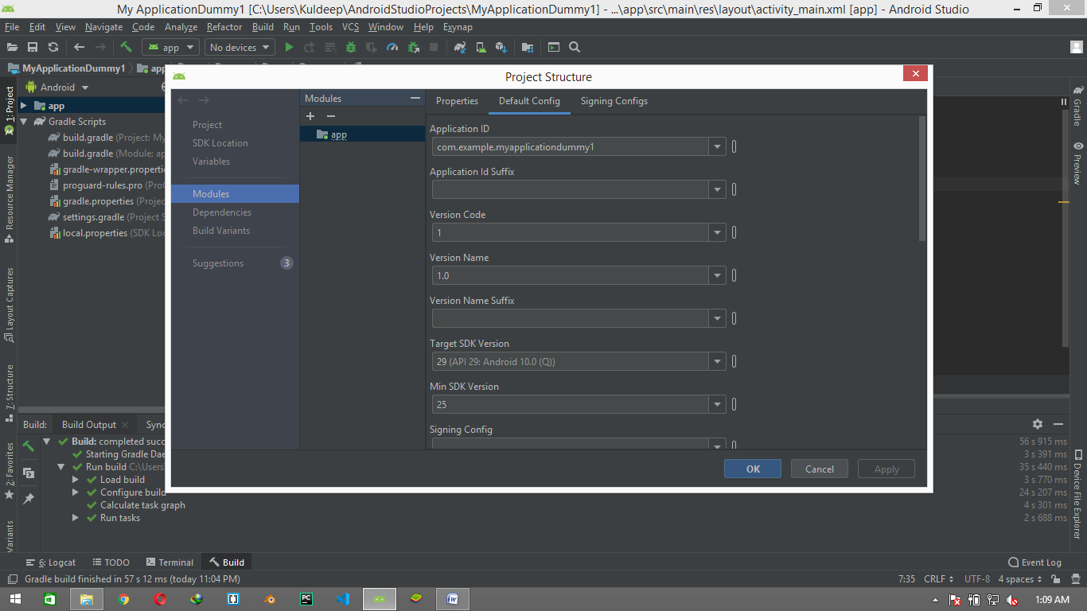

1. Re-build your Project in android Studio . Now your Project is Ready to install in BlueStack.